**Lab Session 6**

**Ex A:**

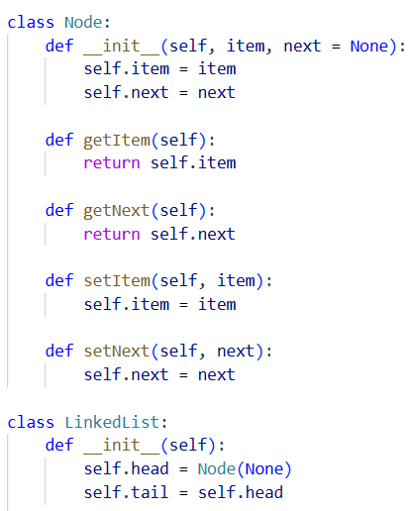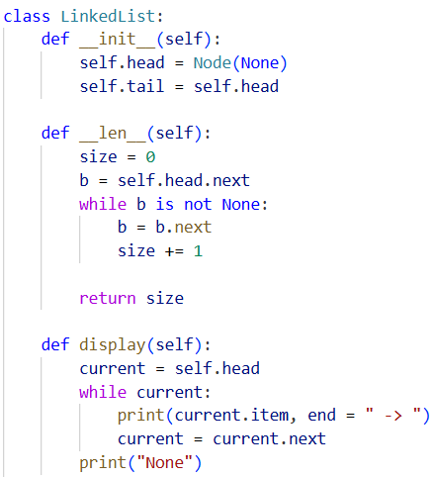**CODE**

**Ex B:**

**CODE**

1. **Insertion**

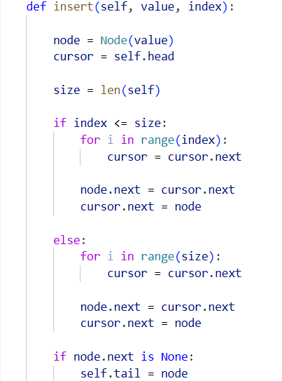

1. **Searching**

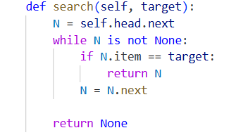**CODE**

1. **Deletion**

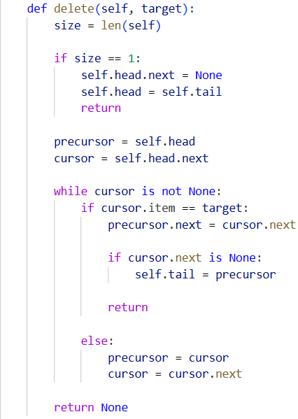**CODE**

**TEST CASES**

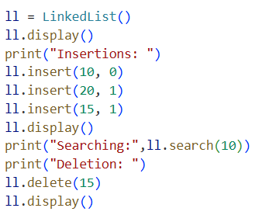

**OUTPUT**

**Ex C:**

**CODE**

**Initial Code:**

1. **A screenshot of a computer code

   AI-generated content may be incorrect.A screenshot of a computer code

   AI-generated content may be incorrect.Insertion:**
2. **Searching:**

1. **A screenshot of a computer program

   AI-generated content may be incorrect.A screenshot of a computer program

   AI-generated content may be incorrect.Deletion:**

**Test Case:**

**OUTPUT**

